MR. PRESIDENT - WHAT DID YOU AGREE TO AT THE G20?
G20 Globalization Thru the World's Education!
Anything, and I mean anything, that has any link or association thru the United Nations is not only New World Oder/One World Government, it can be considered evil. The fact they continually want to use our children for their devious, dark schemes makes those willing to participate as devious and dark.
This past February 2017, so called senior leaders of the United Nations gathered to further plot the future of our children's "planned and manipulated" globalized education. Top UN leaders in speaking at this summit for "youth", all demanded that children worldwide be indoctrinated and conscripted to help impose the UN’s extreme vision on humanity.
For you see "education threatens sustainability" and to the globalist’s, education is the main threat to sustainability and sustainability is the "gut and scam" of the New World Order.
According to the United Nations mindset of which is supported by Marc Tucker's letter to Hillary Clinton and remarks made by many other globalists, the plan for some time was to use our children and their education to "Dumb Down America".
These UN leaders claim this "globalized education" must be imposed on every child on the planet to advance the UN's radical plan for humanity known as “Agenda 2030.” Speakers at the so-called “High-Level Event on Education,” including Muslims and communists, all agreed that UN-led “education” was the key to realizing their globalist goals.
#3 of Agenda 2030 states, " We resolve, between now and 2030, to end poverty and hunger everywhere; to combat inequalities within and among countries; to build peaceful, just and inclusive societies; to protect human rights and promote- gender equality and the empowerment of women and girls; and to ensure the lasting protection of the planet and its natural resources. We resolve also to create conditions for sustainable, inclusive and sustained economic growth, shared prosperity and decent work for all, taking into account different levels of national development and capacities."
Given this is one of the main reasons the UN was created in the first place and given the very same countries are still living within poverty, hunger, and inequalities - what has the UN been doing with the billions of dollars the United States has been giving them over the past 70 years?
#4 states, "Ensure inclusive and equitable quality education and promote lifelong learning opportunities for all - and this sounds really great and being as what I see as one of the easiest goals for the UN to have completed over the past 70 years."
Even though the U.S. Senate has not ratified all this, what goal 4 is really calling for in detail is that all children learn not to just accept and submit to “sustainable development,” but to “promote sustainable development.” This whole agenda has been pushed in our schools and libraries for years now. This is the most important of the 17 goals. How do I know this???
Because the day before the G20 started, there was another gathering regarding education, specifically addressing Goal #4 - "Achieving Sustainable Development Goal". The event itself was titled, "Global Education Before the G20 Summit" - July 6, 2017. This statement is in their summary - "Education is central to the development and to the achievement of all of the Sustainable Development Goals (SDGs)".
Within this document it also clearly states "UN/UNESCO Education Commission estimates expenditure on Education needs to rise from $1.2 TRILLION to $3 TRILLION per year until 2030. Link
#7 states, " In these Goals and targets, we are setting out a supremely ambitious and transformational vision. We envisage a world free of poverty, hunger, disease and a world where all life can thrive. We envisage a world free of fear and violence. A world with universal literacy. A world with equitable and universal access to quality education at all levels, to health care and social protection, where physical, mental and social well-being are assured. A world where we reaffirm our commitments regarding the human right to safe drinking water and sanitation and where there is improved hygiene; and where food is sufficient, safe, affordable and nutritious. A world where human habitats are safe, resilient and sustainable and where there is universal access to affordable, reliable and sustainable energy.
Yet, they have had 70 years in cooperation to carry off these goals and targets and have succeeded in NOTHING but turmoil, hate and discontent mostly on the financial aid of the U.S.
The Sustainable Development Goals or SDG's is really nothing more than a pre-planned recipe for global government and socialism using the United Nations view and vision of "education for all" to be at the very core and heart of the whole thing.
Our children according to the UN are described as "critical agents of change" whose "infinite capacities for activism" will be weaponized and channeled by the UN's plans (schemes) into advancing their global vision of the future.
But this is where they get the world and fool those of us who must depend on the scraps of information we receive on the schemes and lies being used regarding "sustainable development".
The whole scheme, especially the part in relation to education, is being justified to leaders and parents under the guise of supporting sustainable development, but in truth, the UN has already made it very clear that the children being given MORE education are a THREAT to sustainability.
You see Mom and Dad, their rationale is that the more highly educated a person becomes, they have higher incomes, with more money to spend, increasing the number of resources they use over the uneducated people (United State/Great Britain v. Laos/Cambodia). So, to maintain what they believe sustainable development to be, education of the world MUST be kept to a minimum and under the control of the UN/UNESCO.
Watching those behind this worldwide scheme being backed by the establishment globalists, communists, and other tyrants for planetary economic controls, population reduction, global governance, pseudo-environmentalism, wealth redistribution, and technocratic rule, we must remember it is those like Bill Gates, Bill Ayers, Al Gore, George Soros and sons, Prince Charles and others like them who have the multiple mansion homes using multi-billion kilowatts of electricity and airplanes polluting the air, who are certainly not as green as they would like you to think.
No, I am not against someone being a billionaire - I am against their using their wealth and fortune to destroy our world and the futures of our children. No, their plans never include their children as they have had their own private educations and will follow in their father's agendas.
So, where are we? This past June 2017, education leaders from around the world joined together at the United Nations to discuss ways to advance action on Sustainable Development Goal 4 specifically, which aims to “ensure inclusive and quality education for all and promote lifelong learning.”
“Inclusive, equitable and quality education goes to the heart of the 2030 Agenda as a key enabler of sustainable development,” said Peter Thomson, President of the General Assembly, in his opening remarks at the High-level SDG Action Event on Education.
Mr. Thomson pointed out that education taps the Earth’s greatest asset, namely the inherent potential of the world’s people.
“Access to quality education is not only a goal in itself, but a fundamental building block to creating a better world of sustainable peace, prosperity, and development,” he underscored.
He went on to explain that education holds the key to fueling sustainable growth, building social cohesion and stability, and promoting human rights and equality – calling it “the golden thread that runs through all 17 SDGs.”
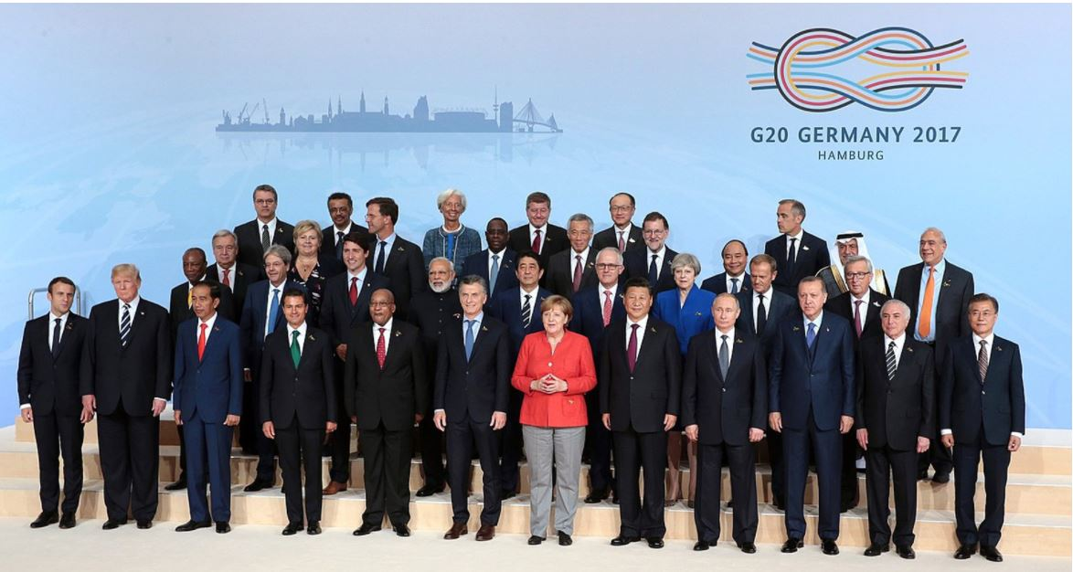
So, America what really happened at the G20? I can tell you and it's not pretty. Made up of 20 governments and dictators, they supposedly all agreed to a document supporting various globalist schemes. Taking what they considered a vacation from discussing the NWO, they turned their attention to "global education shaping the interconnected world".
At the top of the list was a request for an additional $3.1 billion to eannsure all children of the world are being offered an education since UNESCO claims there are over 130 million children who are uneducated. What they are talking about is not "real" education, but "sustainable education". There is a real difference.
At the front of this mess is the Global Partnership for Education which is a globalist front group which has been working to bring this globalist indoctrination to all the children of the world under the guise of "education". Yes, U.S. taxpayers are funding this also through the UN.
This group is looking for $39 billion to see that all children are educated by their 2030 goal. They are also pushing the idea that educating girls has a "multiplier" effect since educated women are "healthier, have fewer children, and earn more income.
American parents need to know that the pampered education agency of the UN, "UNESCO" is being run by the Bulgarian Communist Irina Bokova, and among UNESCO's long-term partners are UNICEF and the World Bank. Danger!
What we all were not aware of at the time was in June 2016, there was a UN summit held in Korea where they "adopted a global action plan demanding a planetary "education" regime to transform children around the world into social-justice warriors and sustainability minded "global citizens".
The controversial action plan, approved by the UN's propaganda department and a group of largely government-funded “non-governmental organizations” (NGOs) at the June 2016 event, was aimed at helping the UN impose its Agenda 2030 scheme to “transform the world.” In fact, the title of the summit gave away the agenda: “Education for Global Citizenship: Achieving the Sustainable Development Goals Together.” Link
The global “Education Commission,” chaired by former U.K. Prime Minister and longtime “New World Order” pusher Gordon Brown and guided by various UN agencies and socialist and Islamist regimes, was also pleased with the G20 emphasis on “education.”
The UN/UNESCO globalists speak in double-speak giving 2 sided messages as in claiming our children need to be educated for the purpose of being healthy and living longer, yet their population control agenda is also very high on the ladder of achievements.
Instead of thinking they are so much smarter than we are, they need to just come right out and clearly state their intentions - they are either proud of them or afraid we are smarter than they are!
UNESCO is "warning" aid for education has been falling for the last 6 years - I wonder if these are the same nations not pulling their weight regarding NATO.
UN/UNESCO are always calling for more money, but give NO accounting as to where all the billions they have received over the last 70 years has been spent and why the poor that were poor and uneducated 70 years ago, still are!
UNESCO's new agenda is "early learning" of which we here in the U.S. have already started, keeping in mind early learning is not necessarily a bad thing, it's what they are being taught, who is teaching it and who is paying for it that is causing the problems for the world.
The list of the AGREED TO DOCUMENTS AT THE G20 and can be found within the G20 Leaders Declaration.

Mr. President, what did you sign at the G20 and
commit America To?

Truth is, the United Nations “Agenda 2030,” also known as the Sustainable Development Goals, centers on globalized indoctrination and a deliberate dumbing down of humanity. It is being done under the guise of “education,” but Agenda 2030 and other UN documents make the true nature of the program crystal clear. Do your research America - it is out there. I found it!
Time for the U.S. to get OUT of the UNITED NATIONS!
The Sooner - The Better!
I remind my readers an article I wrote and published on Nov 9, 2015 on News with Views stated Christiana Figueres, the Executive Secretary of the United Nations Framework Convention on Climate Change (UNFCCC), warned that the fight against climate change is a process and that the sought-after transformation of the world economy will not be decided at one conference or in one agreement.
Figueres expressed that UNFCCC has a goal of environmental activists NOT to save the world from ecological calamity, but to destroy capitalism. She went on to state, "This is the first time in the history of mankind that we are setting ourselves the task of intentionally, within a defined period of time, to change the economic development model that has been reigning for at least 150 years, since the Industrial Revolution.”
This arrogant, power hungry woman needs to be reminded the only economic model in the last 150 years that has ever worked at all is capitalism. The evidence is prima facie: From a feudal order that lasted a thousand years, produced zero growth and kept work days long and lifespans short, the countries that have embraced free-market capitalism have enjoyed a system in which output has increased 70-fold, work days have been halved and life spans doubled.
According to Figueres, "the United States CANNOT leave the Climate Agreement until 2020 at the earliest so she is not concerned about Donald Trump"! We should be concerned that it is a lie, scam and meant to destroy us!
This article was written with information gathered from various sources including Alex Newman, The New American and G20 documents.

